**Screenshots**

New User UI (Sign up)

Login page

Overview page (home page)

List of loans UI

Error free connection to DB:

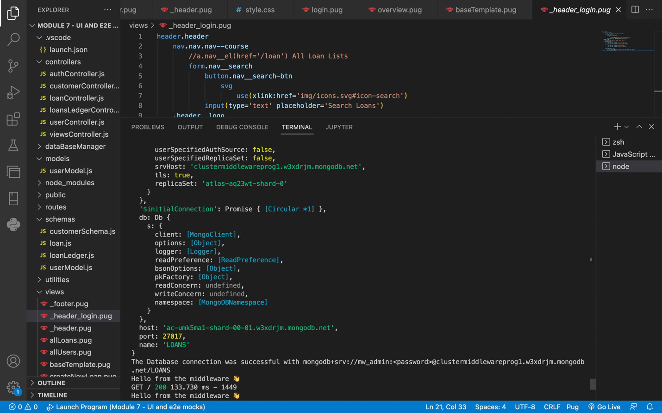

**Routes and controllers used**

New user creation:

/users/signup, method=POST, controller = authController.signup

Login user:

/users/login, method=POST, controller = authController.login

Create new loan:

/loan, method=POST, controller = loanController.createLoan

List of loans:

/loan/allLoans, method=GET, controller = loanController.getLoanByUserID

**Flow diagrams**

Overview (homepage):

Sign up page:

Create new loan:

Login page:

All loans page:

**Data Models**

Users

Loans

**GitHub link**

<https://github.com/vsasanka/IFT598MiddlewareProg-DBSecurity/tree/main/Final%20project>

**Recordings**

Please find the project demo in the ‘Recording 1 - sign up, login, loan creation.mov’ and ‘recording 2 - list of loans by a user.mov’ files.

**Postman calls**

The below screenshots of postman contain the outputs for APIs on creation and listing of users and loans. This project has been designed such that the responses of these APIs are to render the results into HTML pages. Hence, the response section of each API calls below show HTML codes.

User creation - Sign up

User Login

Create a new loan

List of loans

List of users

**Learnings from Module 1 to Module 8**

The course is aptly termed as middleware programming and database security, as it precisely describes my learnings in this course. To begin with, I have learned fundamentals of JavaScript. I went on to learn to create a node server, and show an output there. Soon, we were introduced to app creation using ExpressJS, integration of our application MongoDB, and using Microsoft MSSQL (in which, we revised using SQL joins to query multiple tables). Furthermore, we our introduction to MVC architecture began, which has been the crux of our learning in the course. I went ahead to implement authentication and authorization techniques using JWT token. This enabled me to understand the intricacies of login/logout, and got hands on experience on operating with session cookies. Almost to the end, I learned to use PUG format, which seems to be an enhanced version of HTML, with advanced capabilities like loops and conditions, something which is missing in HTML. In the final project, I stitched all my learnings together to create a few complete flows like user sign up, login, loans creation and viewing list of loans specific to the user. Overall, it has been a great learning experience of middleware programming and database security.